“SECURED MESSAGE SENDING PLATFORM”
Using Python and ML
Project Report

By: Anurag Wande

(intern at. EXPOSYS DATA LABS)_
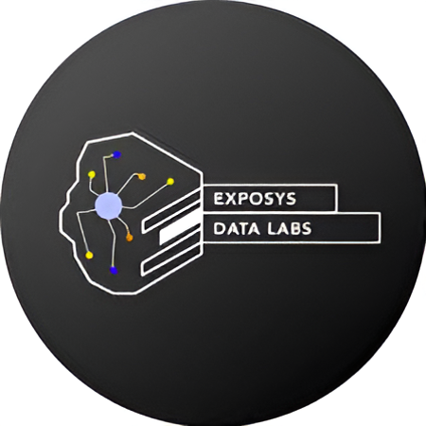

Our Mission
To Tap and train best brainpower to give solutions
for real challenges of the world

TABLE OF CONTENTS

- ABSTRACT

- INTRODUCTION

- EXISTING METHOD

- PROPOSED METHOD WITH ARCHITECTURE

- METHODOLOGY

- IMPLEMENTATION
6.1 FRONTEND
6.2 BACKEND
- CONCLUSION

1. ABSTRACT

The project addresses the critical need for secure communication over cloud platforms by developing a secure messaging application using Flask, Python, and advanced cryptographic techniques.
The application consists robust user authentication, along with encryption and decryption processes that protect sensitive information during transmission. By implementing a modified cryptographic algorithm and a secure SQLite database for user management, the application enhances data security while maintaining efficiency and usability.

2. INTRODUCTION

In the digital age, the security of personal messages and files has become most important. As data often moves through various cloud services, the risk of unauthorized access increases. This project aims to create a secure messaging platform that utilizes encryption and user authentication to safeguard messages sent between users. The system is designed to ensure data integrity and confidentiality, while providing a user-friendly experience

3. EXISTING METHOD

Traditional messaging systems often have significant security shortcomings, including:

- Weak Password Storage: Many systems store passwords in plaintext or use outdated hashing methods, making them vulnerable to breaches.

- Lack of End-to-End Encryption: Messages are frequently encrypted only during transit, not on the sender's device, exposing them to interception.

- Inadequate User Authentication: Simple username and password combinations are common, lacking additional security measures like multi-factor authentication (MFA), which increases vulnerability to attacks.

- Vulnerability to Interception: Without secure transmission protocols (e.g., HTTPS), messages can be intercepted by attackers, compromising confidentiality.

- Poor Session Management: Ineffective handling of session tokens can lead to session hijacking, allowing unauthorized access to user accounts.

4. PROPOSED METHOD WITH ARCHITECTURE

The proposed secure messaging application integrates advanced encryption techniques through the Fernet symmetric encryption method, which is part of the cryptography library. This ensures that messages are securely encrypted before they are sent and can only be decrypted by the intended recipient using a unique key. User authentication is managed through a combination of hashed passwords using HMAC and SHA-256, and a SQLite database is used to securely store user credentials and messages.
The architectural design consists of a Flask web application that serves as the backend, with routes for user authentication and messaging functionalities. The frontend, developed using HTML and CSS, provides a clean, user-friendly interface, allowing users to easily navigate the application and manage their communications securely.

5. METHODOLOGY

The series if methodologies are
- Database Setup: A SQLite database was established to manage user information and messages securely.

- User Registration and Authentication: The system allows users to register/sign up with a unique username and password, which is securely hashed and stored. Users can authenticate using their credentials to access the messaging platform.

- Message Handling: The application implements functions to encrypt messages using the recipient's unique key and store them in the database securely.

- Web Development: Using Flask, web routes were created to handle user interactions, including sending and receiving messages. The frontend was developed using HTML and styled with CSS for enhanced usability.

- Testing: The application underwent testing to ensure that all functionalities work correctly and securely.

6. IMPLEMENTATION

The implementation was done
in majorly Two parts

6.1 Front-End:
User Interface:
- The application provides a clean and responsive user interface that allows users to easily navigate through various functionalities such as login, sign-up, and message sending.
- HTML forms are utilized for user input, including username and password for authentication, as well as fields for sending messages.
Styling:
- CSS is employed to enhance the visual appeal and usability of the application. Elements like navigation menus, buttons, and input fields are styled for better user experience.
- The design is responsive, ensuring that the application is accessible on various devices, including desktops and mobile phones.
User Feedback:
- The frontend includes dynamic elements that provide user feedback, such as error messages for failed login attempts or successful message transmissions. This helps in guiding users through the application smoothly.

Front-End Images : -

Login Page
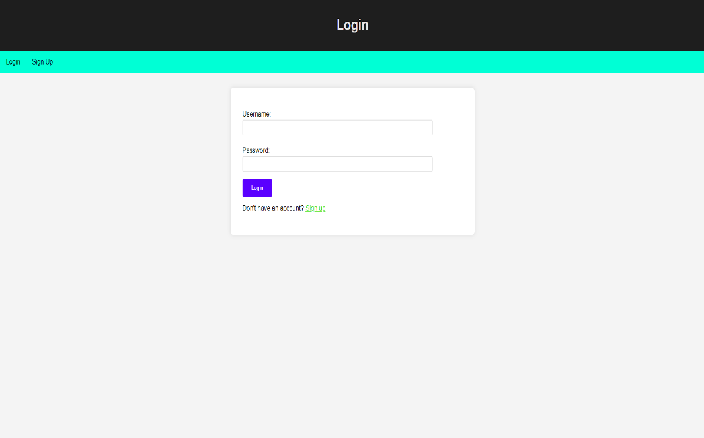

Sign Up page
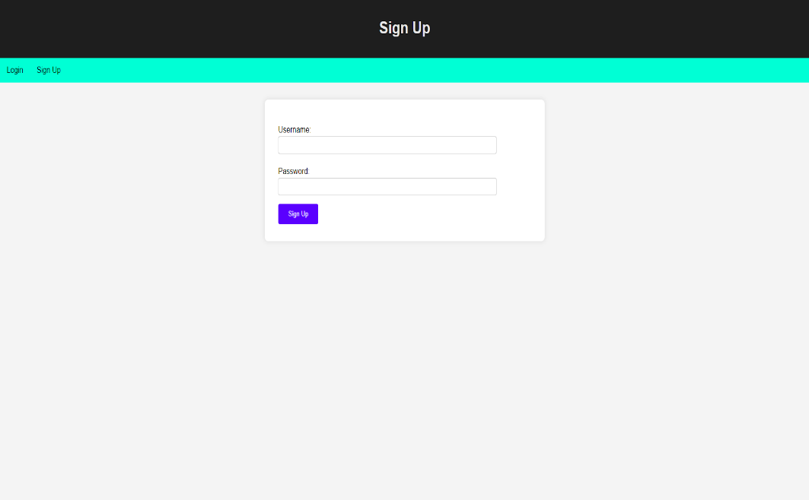

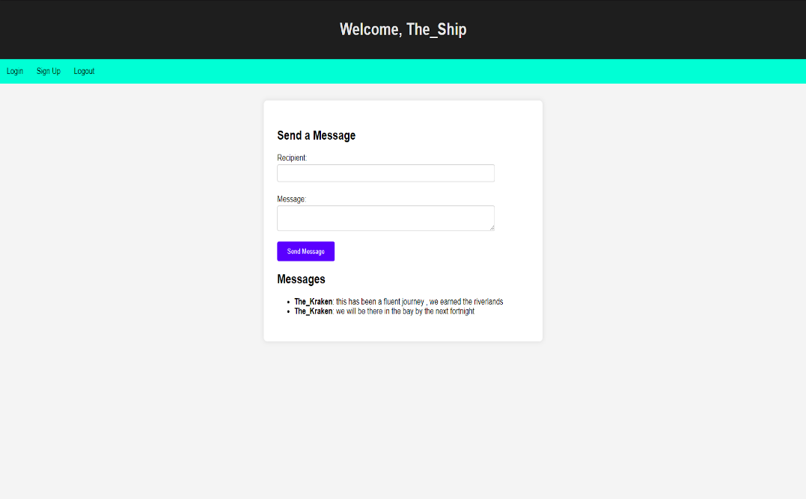
Dashboard

6.2 Backend

The backend is built using Flask, a lightweight web framework for Python, which handles the application’s logic and data management.
Database Management:
- A SQLite database is used to store user credentials and messages securely. This includes tables for user information and encrypted messages, ensuring data integrity and security.
User Authentication:
- The backend implements secure user registration and login processes. Passwords are hashed using HMAC with SHA-256 before being stored, enhancing security against unauthorized access.
Message Encryption and Decryption:
- The backend features functions to encrypt messages using the Fernet symmetric encryption method from the cryptography library. This ensures that messages are securely transmitted and can only be decrypted by the intended recipient using their unique key.
Routing and Session Management:
- Flask routes manage user interactions, directing them to appropriate pages for login, sign-up, and dashboard functionalities. User sessions are handled securely to maintain user state across different interactions.
Error Handling:
- The backend includes error handling to manage exceptions gracefully, providing meaningful feedback to users in case of issues like failed authentication or message delivery problems.

Back-End Images

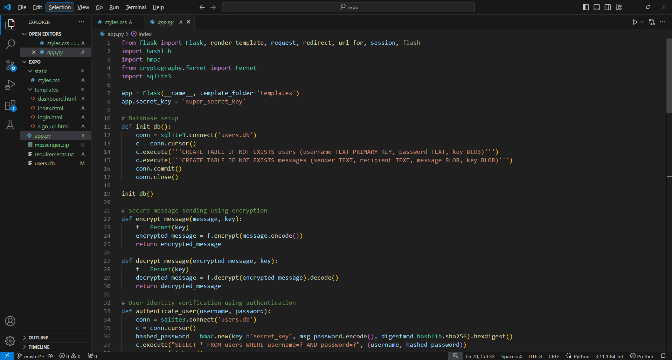
APP.PY

7.CONCLUSION

The secure messaging application effectively addresses the crucial need for secure communication in an increasingly digital world. By implementing robust encryption and authentication mechanisms, the application significantly reduces the risks associated with data breaches and unauthorized access. This solution not only provides users with peace of mind regarding the confidentiality of their messages but also enhances the overall integrity of the communication process. Future improvements could involve integrating machine learning algorithms for anomaly detection in user behavior, thereby further enhancing security, as well as exploring additional encryption methodologies to stay ahead of evolving security threats.

